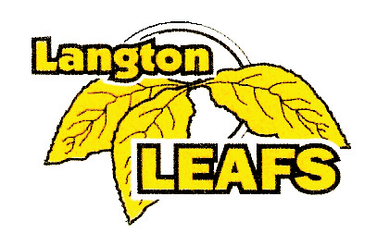

JOE CALLENS MEMORIAL REP TOURNAMENT
NOVICE, ATOM, PEEWEE REP
C, CC, D, DD, E, AE4, AE5
December 8, 9, 10, 2017
$850.00
GUARANTEED 3 GAMES
TREATS FOR EACH PLAYER
AWARDS FOR THE FINALISTS
VALID OMHA TRAVEL PERMIT REQUIRED

CONTACT: LYNDA MATTHEWS
Cell: 519-875-3246
EMAIL: matthews@flarenet.com

LANGTON & AREA MINOR HOCKEY
C/O LYNDA MATTHEWS
1655 FORESTRY FARM RD.
R.R. #6 SIMCOE, ON N3Y 4K5

