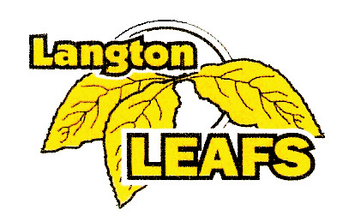

LANGTON
BANTAM AND MIDGET REP
TOURNAMENT
C, CC, D, DD, AE4, AE5
NOVEMBER 17, 18, 19, 2017
$850.00
GUARANTEED 4 GAMES
TREATS FOR EACH PLAYER
AWARDS FOR THE FINALISTS
VALID OMHA TRAVEL PERMIT REQUIRED

CONTACT: LYNDA MATTHEWS
PH: 519-875-3246
EMAIL: matthews@flarenet.com

LANGTON & AREA MINOR HOCKEY
C/O LYNDA MATTHEWS
1655 FORESTRY FARM RD.
R.R. #6
SIMCOE, ON N3Y 4K5

